Measure of central tendency;

Code;

Output

Measure of spread

Code

Output

Normallization

Code

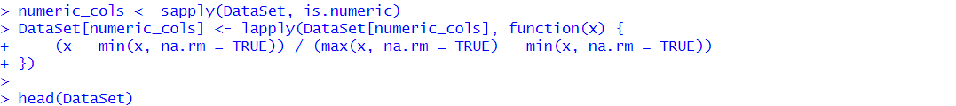

Output

